mAmerican International University- Bangladesh
Department of Electrical and Electronic Engineering
COE 3201: Data Communication Laboratory

Title: Study of Nyquist bit rate and Shannon capacity using MATLAB
Abstract:
This experiment is designed to-

- To understand the use of MATLAB for solving communication engineering problems.
2.To develop understanding of Nyquist bit rate and Shannon capacity using MATLAB.
Introduction:
- Nyquist Bit Rate: The Nyquist bit rate formula defines the theoretical maximum bit rate for a noiseless channel.

$$BitRate=2 × bandwidth × \log_{2}L$$

In this formula, bandwidth is the bandwidth of the channel, L is the number of signal levels used to represent data, and BitRate is the bit rate in bits per second.

- Shannon capacity: Shannon capacity formula was introduced to determine the theoretical highest data rate for a noisy channel:

$$Capacity= bandwidth × \log_{2}(1+ SNR)$$

In this formula, bandwidth is the bandwidth of the channel, SNR is the signal-to-noise ratio, and capacity is the capacity of the channel in bits per second.

Signal-to-noise ratio (SNR): To find the theoretical bit rate limit, we need to know the ratio of the signal power to the noise power. The signal-to-noise ratio is defined as

$$SNR=\frac{Average Signal Power}{Average Noise Power}$$

We need to consider the average signal power and the average noise power because these may change with time.
A high SNR means the signal is less corrupted by noise; a low SNR means the signal is more corrupted by noise.
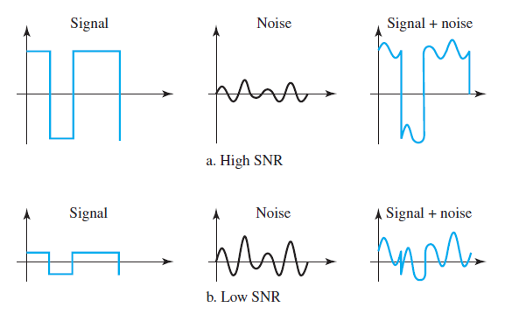

Fig: Two cases of SNR: a high SNR and a low SNR

Because SNR is the ratio of two powers, it is often described in decibel units,
SNRdB, defined as

$${SNR}_{dB}=10\log_{10}(SNR)$$

Example of Nyquist bit rate calculation for a noiseless channel:

close all;
clc;
fs = 8000; % Sampling frequency
t = 0:1/fs:1-1/fs; % Time duration
cx = 1.1*sin(2*pi*100*t) + 1.3*cos(2*pi*300*t) + 1.5*sin(2*pi*2000*t);
bandwidth = obw(cx,fs); % Bandwidth of the signal
L=2; % Level of the signal
BitRate = 2*bandwidth*log2(L)

Output:
BitRate =

3.8019e+03

Example: Calculation of SNR
close all;
clc;
%Define number of samples to take
fs = 8000; % Sampling frequency
f = 400; %Hz
%Define signal
t = 0:1/fs:1-1/fs;
A = 3.0;
powfund = A^2/2
s = 0.1;
varnoise = s^2;
signal = A*sin(2*pi*f*t);
%noise
noise = s*randn(size(signal));
%noisy signal
noisySignal = signal + noise;

SNR = snr(noisySignal) %Calculation of SNR using snr function

defSNR = 10*log10(powfund/varnoise) %Calculation of SNR following the definition

SNR =

26.2571

defSNR =

26.5321

Similar task can be done considering a noisy composite signal. Suppose our composite signal is,

signal = 1.5*sin(2*pi*2*t)+0.9*cos(2*pi*10*t)+1.1*sin(2*pi*20*t) + 0.13*randn(size(t));

*****Calculate the SNR value of the signal.

Example of Shannon capacity calculation for a noisy channel:
clc
close all
fs = 8000; % Sampling frequency
f = 3; %Hz
%Define signal
t = 0:1/fs:1-1/fs;
A = 2;
s = 0.4;
%signal
x = A*sin(2*pi*f*t);
%noise
ns = s*randn(size(signal));
S_N_R = snr(x,ns);

bandwidth = obw(x,fs); % Bandwidth of the signal
%capacity
C = bandwidth*log2(1+SNR) % Capacity of the channel

C =

6.6576e+04

Performance Task for Lab Report: (your ID = AB-CDEFG-H)
**Generate a composite signal using two simple signals as,
x = A₁ sin(2π((C+D+H)*100)t ) + A₂ cos(2π((D+E+H)*100)t) + s*randn(size(t));

(a) Select the value of the amplitudes as follows: let A₁ = (A+B+H), A₂ = (B+C+H) and s = (C+D+H)/30
(b) Calculate the SNR value of the composite signal.
(c) Find the bandwidth of the signal and calculate the maximum capacity of the channel.

(d) What will be the signal level to achieve the data rate?

